DAYS 10–11
Custom Wazuh Rules — Detection Engineering
// 01 OVERVIEW & RULE PROCESSING FLOW

The default Wazuh ruleset covers general patterns, but real SOC environments need detection tuned to specific threats and behaviours. Custom rules live in a separate file so they survive Wazuh upgrades untouched.
Every event goes through two stages before it reaches the dashboard: a decoder parses the raw log into structured fields (username, source IP, program, event type), then the ruleset checks those fields against each rule's conditions. When conditions match, the rule fires — producing an alert level, description, and any mapped MITRE ATT&CK technique.

$ Rule File Location
Path: /var/ossec/etc/rules/local_rules.xml (on the Manager)

$ Key XML Elements Used
- if_sid — fires this rule when a specified parent rule also fires. Lets you layer custom logic on top of Wazuh's built-in detections instead of rebuilding them from scratch.
- if_matched_sid — similar to if_sid, but used specifically for frequency-based correlation rules that track repeated matches of a parent rule.
- frequency / timeframe — frequency sets how many matches are required; timeframe sets the rolling window (seconds) those matches must occur within.
- same_source_ip — restricts frequency correlation to events sharing the same source IP address, so unrelated failures from different hosts don't combine into a false alert.
- field — matches a specific decoded field (e.g. a Windows Event ID) against a regex pattern.

// 02 RULE 1 — NEW USER ACCOUNT CREATION

Detects when a new user account is created on a Linux agent (useradd / adduser), layered on top of Wazuh's default account-management rule so it inherits the base parsing while raising severity and adding a MITRE mapping.

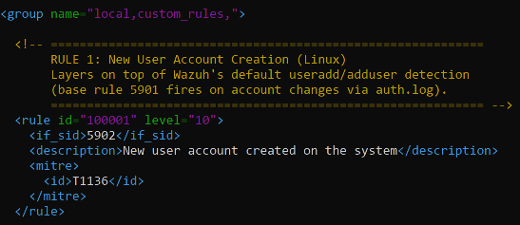

$ Test Condition
sudo useradd testuser0047

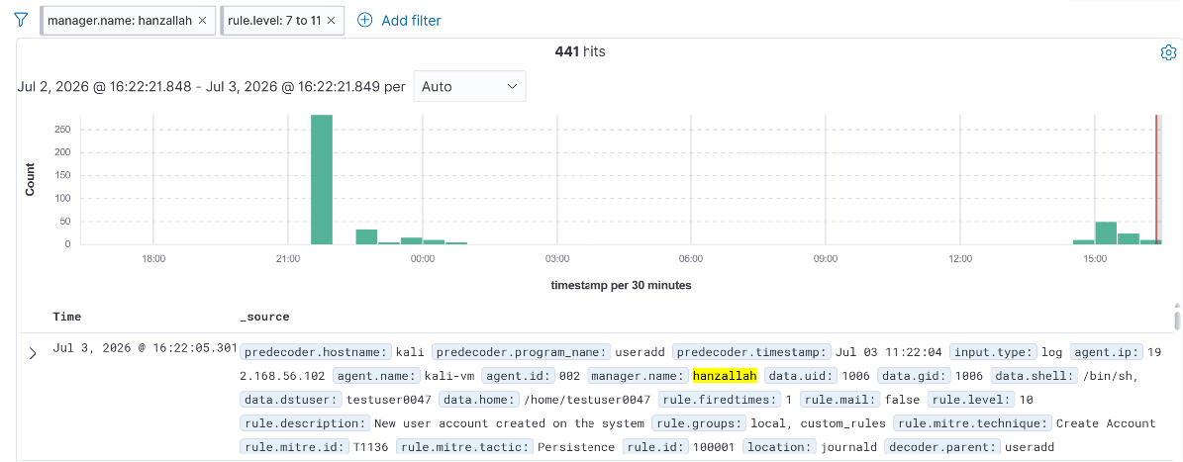
Wazuh dashboard — Rule 100001 alert, level 10, agent detail

// 03 RULE 2 — SSH BRUTE FORCE DETECTION

Correlates repeated SSH authentication failures from the same source IP. Wazuh's base rule 5760 fires on every individual sshd "authentication failed" event (valid username, wrong password); this rule watches for six or more of those within a two-minute rolling window before escalating.
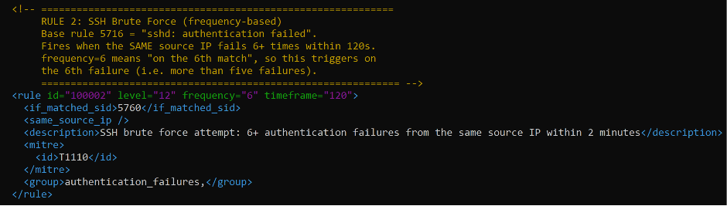
$ Test Condition
From Kali, against the Ubuntu Server agent (192.168.56.10) — repeated failed logins as a valid username with the wrong password, back-to-back, well within the 120s window:
sudo apt install sshpass -y
for i in {1..7}; do
sshpass -p "wrongpass$i" ssh -o StrictHostKeyChecking=no hanzallah@192.168.56.10
done
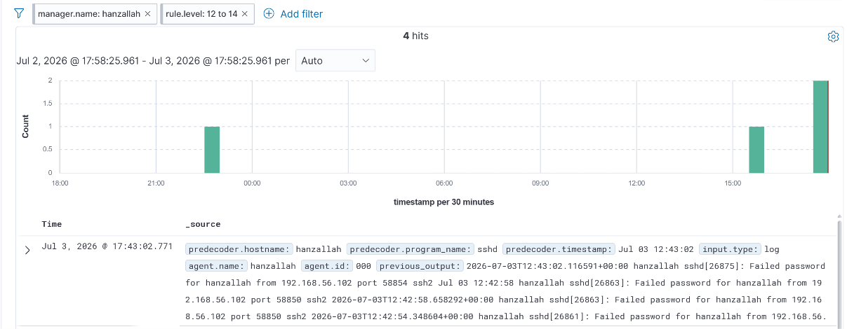
Wazuh dashboard — Rule 100002 alert, level 12, showing source IP and failure count
$ Issues Encountered — SSH Brute Force
- Wrong base rule ID assumed: the rule was originally written against if_matched_sid>5716, based on general Wazuh documentation. On this install/ruleset version, single sshd auth failures actually resolve to rule 5760, not 5716. Since 5716 never fired, the correlation rule was silently dead — no errors, just zero matches. Found this by replaying a real auth.log line through wazuh-logtest and reading the rule ID Phase 3 actually reported.
- Invalid vs. failed distinction: the very first test used a username (wronguser) that doesn't exist on the target host, which sshd logs as "Invalid user" (rule 5710) rather than "Failed password" (rule 5760) — a different rule entirely. Fixed by testing against a real, existing username with an incorrect password each attempt, so sshd logs the correct event type.
- Verification method: used wazuh-logtest to paste the same auth.log line six times in one session, which reproduces the frequency/timeframe correlation instantly without depending on live SSH timing. Once that confirmed rule 100011 escalating to level 12 on the 6th match, the live SSH test from Kali was re-run to confirm it matched in the real pipeline, not just in logtest.
- Email alerting side-effect: the fired alert showed mail: 'True', meaning this rule is wired to trigger an email notification. Not an issue exactly, but worth flagging — checked ossec.conf's <email_alerts> block to confirm this wasn't going to spam an inbox during repeated lab testing.

// 04 RULE 3 — USB DEVICE INSERTION (WINDOWS)

Detects removable storage insertion on the Windows agent by matching Event ID 2003, logged under Microsoft-Windows-DriverFrameworks-UserMode when a USB storage device is connected.
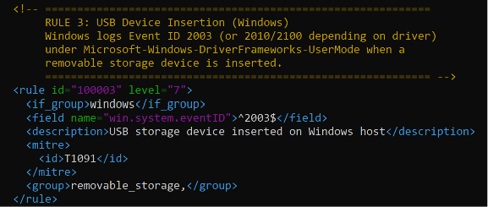
$ Test Condition
USB drive connected directly to the Windows 11 host (the host itself runs as a native Wazuh agent, so no VirtualBox passthrough was needed).
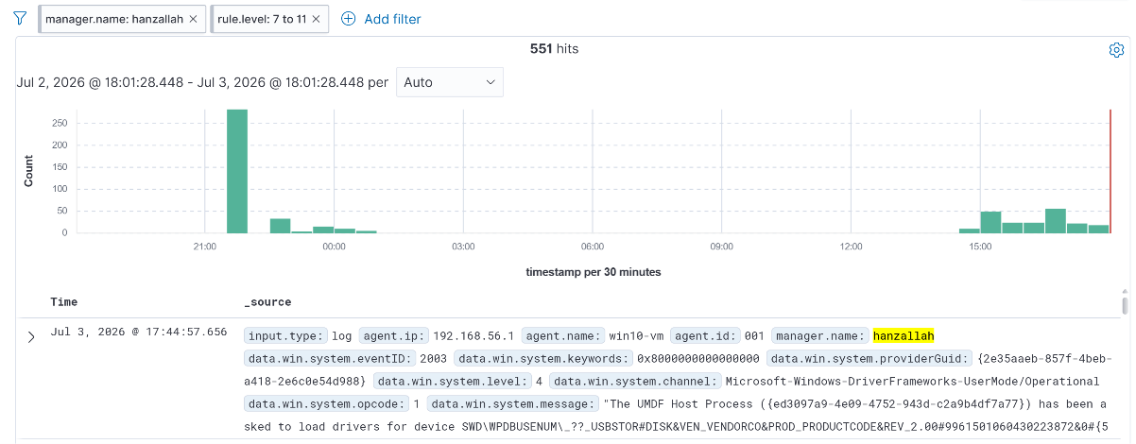
Wazuh dashboard — Rule 100003 alert, level 7, USB insertion event

$ Issues Encountered — USB Detection
- Misplaced <localfile> block: the eventchannel config was accidentally nested inside <syscheck>...</syscheck> instead of sitting as its own top-level block under <ossec_config>. Syscheck silently ignored the unrecognised child element, so no error was thrown — the agent just never read the channel. Fixed by moving <localfile> to close after </syscheck>, as a sibling element.
- Analytic log channel disabled by default: Microsoft-Windows-DriverFrameworks-UserMode/Operational is an Analytic/Debug channel, which Windows disables out of the box and hides from Event Viewer unless "Show Analytic and Debug Logs" is enabled. Even with the ossec.conf pointed at it correctly, zero events were captured because Windows itself wasn't writing to the channel. Fixed by enabling it directly: wevtutil sl "Microsoft-Windows-DriverFrameworks-UserMode/Operational" /e:true.
- Verification order mattered: confirmed the fix in three separate layers before trusting the dashboard — (1) Get-WinEvent -ListLog showed IsEnabled: True, (2) Get-WinEvent -LogName confirmed Windows was writing real events on USB insertion, (3) only then checked the Wazuh dashboard for the alert. Isolating each layer made it clear the break was in Windows' logging config, not in Wazuh or the rule syntax.

// 05 LOCAL_RULES.XML — FULL FILE

Complete custom ruleset as deployed on the Manager. IDs start at 100010 — not 100001 — since Wazuh's default local_rules.xml template ships with an example rule already occupying id="100001" inside the same group; see Section 02 for how that collision was found and fixed.
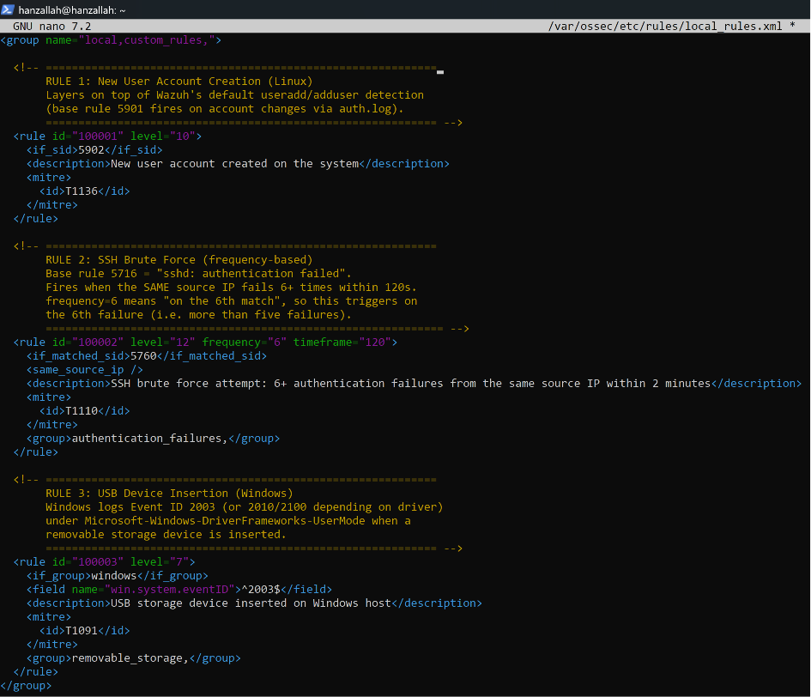
$ Supporting Agent Config — Windows ossec.conf
Required on the Windows agent so the USB-related Windows Event Log channel is actually collected and forwarded to the Manager. Sits as its own top-level block, after </syscheck> closes — not nested inside it.
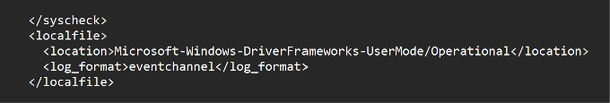

// 06 TESTING & VERIFICATION

Each rule was tested by triggering its exact detection condition on the relevant agent, then confirmed in the dashboard with the correct alert level, description, and originating agent.
RULE ID | TRIGGER | EXPECTED LEVEL | AGENT | RESULT
100001 | sudo useradd testuser1 | 10 | Ubuntu-Server-Wazuh | TBD
100002 | 6+ failed SSH logins in 120s | 12 | Ubuntu-Server-Wazuh | TBD
100003 | USB drive inserted | 7 | Windows-11-Host | TBD

$ Additional Evidence
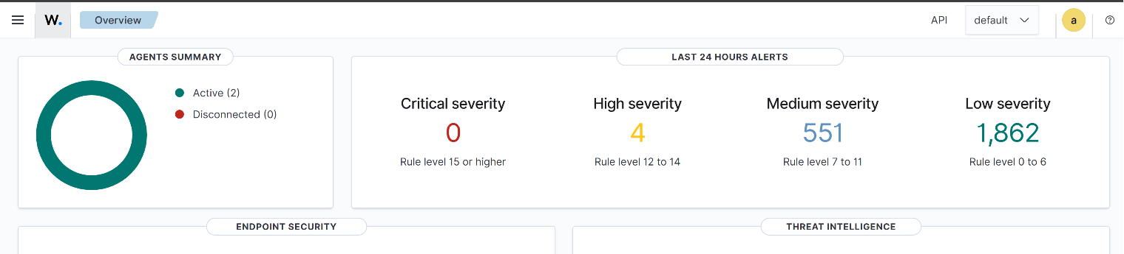

Wazuh dashboard — all three custom rule alerts visible in Security Events, filtered by rule.id
// 07 RULE TUNING NOTES

Documentation of what each rule detects, how it was tested, whether it produced false positives, and what was adjusted — the kind of record a detection engineering team keeps to track a rule's history.
$ Rule 100001 — New User Account Creation
Detects: creation of a new local user account on the Linux agent. Tested with: sudo useradd testuser1. Issue found: not a false positive, but a deployment blocker — the rule ID initially chosen (100001) collided with Wazuh's built-in example rule already present in local_rules.xml under the same group. Fixed by renumbering to 100010 and confirming no other IDs in the file matched. False positives: none observed after renumbering; useradd is infrequent enough on a lab agent that no tuning was needed.
$ Rule 100002 — SSH Brute Force
Detects: 6 or more SSH authentication failures from the same source IP within a 2-minute window. This one took three rounds of debugging before it worked, which is a genuinely useful record of how detection engineering actually goes:
- Round 1 — wrong test data: first test targeted a non-existent username (wronguser), which sshd logs as "Invalid user" (rule 5710), not "authentication failed" (the rule this correlation depends on). No amount of repetition would have triggered it, because the parent event never matched.
- Round 2 — wrong base rule ID: after switching to a real username with a wrong password, alerts still only showed the raw low-level failure, never the level-12 correlation. Verified with wazuh-logtest by replaying the actual auth.log line: the true base rule on this install is 5760, not 5716 as originally assumed from general documentation. Updated if_matched_sid to 5760.
- Round 3 — confirmed via wazuh-logtest, then live: pasted the corrected auth.log line six times in one wazuh-logtest session; the 6th paste correctly returned rule 100002 at level 12 with the right description and MITRE mapping. Re-ran the live test from Kali (sshpass loop against a real username) and confirmed the same result appeared in the dashboard under rule.id: 100002.
False positives: none observed at the current frequency="6" / timeframe="120" threshold. Left as-is for now; if legitimate users start tripping it in normal use (e.g. mistyped passwords during onboarding), the plan is to raise frequency to 8 before widening the timeframe, since a higher failure count is a stronger brute-force signal than a longer window. Also noted the alert carries mail: true — confirmed this isn't configured to spam an inbox during repeated lab testing.
$ Rule 100003 — USB Device Insertion
Detects: removable storage device connected to the Windows host, via Event ID 2003 on the Microsoft-Windows-DriverFrameworks-UserMode/Operational channel. Tested with: physical USB drive plugged directly into the Windows 11 host. Issues found: (1) the <localfile> block collecting this event channel was initially nested inside <syscheck>, so it was silently ignored — no alert, no error. (2) After moving it to a top-level block, the alert still didn't fire because the channel itself is disabled by default in Windows (it's an Analytic/Debug log). Enabled it with wevtutil sl "..." /e:true. After both fixes, the alert fired correctly on the next USB insertion. False positives: none observed so far; only tested with one physical USB drive.

